Silicon Stratigraphy: A Provenance-First Framework for Preserving Pre-LLM Digital Artifacts in Archaeological and Cultural Heritage Contexts

SCOTT J. BOUDREAUX, Elyan Labs, Louisiana, USA

This paper addresses a practical archaeological problem: in AI-mediated workflows, evidence can be transformed faster than provenance can be documented. As archaeological research depends on digital records, weak provenance controls increase the risk that derived outputs are mistaken for primary evidence. The paper proposes Silicon Stratigraphy, a provenance-first framework that separates source layers, records transformations, and preserves fixity evidence. The method combines OAIS-aligned archival practices, web time-state capture, PROV-O lineage metadata, and cryptographic commitments that can be independently audited. The contribution is methodological and practice-oriented: a repeatable protocol for archaeological and cultural heritage teams that use contemporary AI tooling while maintaining evidentiary integrity. The framework is demonstrated in a working implementation and evaluated through reproducibility-oriented criteria relevant to archaeology.

Keywords:

digital archaeology, cultural heritage, provenance, research reproducibility, archival integrity, generative AI

SDH Reference:

Boudreaux, Scott J. 2026. "Silicon Stratigraphy: A Provenance-First Framework for Preserving Pre-LLM Digital Artifacts in Archaeological and Cultural Heritage Contexts." Studies in Digital Heritage, submitted manuscript.

https://github.com/Scottcjn/echoes-silicon-age-bridge

1. INTRODUCTION

Archaeological interpretation increasingly relies on digital evidence: excavation archives, project databases, site photographs, scanned plans, web publications, code repositories, and born-digital documentation. At the same time, research teams now use large language models and related generative systems for summarization, translation, classification, coding, and visualization. These tools are useful, but they introduce a new risk: secondary outputs can be produced rapidly and distributed widely without sufficient provenance metadata. When source and derivative records become entangled, archaeological claims can lose auditability.

This risk is not abstract. Archaeology has long emphasized context, stratigraphy, and chain of custody in physical evidence. Digital evidence requires equivalent rigor. Open data ecosystems and computational pipelines have already shifted archaeological practice toward software-dependent interpretation, which increases the importance of transparent metadata, workflow traceability, and reproducibility (Kansa 2012; Marwick 2017). In a post-LLM environment, these requirements intensify.

This paper proposes Silicon Stratigraphy, a provenance-first framework designed for archaeological and cultural heritage contexts where teams must preserve pre-LLM sources while also using post-LLM tooling. The method does not reject AI tools. Instead, it formalizes a boundary between source evidence and derived products so that interpretation remains testable.

1. RESEARCH QUESTIONS

The manuscript addresses three research questions:

RQ1. How can archaeological teams preserve source digital artifacts in a way that keeps them distinguishable from AI-mediated derivatives?

RQ2. Which minimal metadata and fixity controls are required to make transformations auditable by third parties?

RQ3. Can a provenance-first workflow improve reproducibility and confidence in archaeological digital interpretation without blocking practical use of modern tooling?

1. BACKGROUND AND STANDARDS

Silicon Stratigraphy builds on existing standards rather than introducing a parallel preservation doctrine. OAIS remains the canonical reference model for ingestion, storage, management, and dissemination of archival information packages (Consultative Committee for Space Data Systems 2012). For web-delivered evidence, RFC 7089 Memento is critical because it permits explicit retrieval of resource states by datetime (Van de Sompel et al. 2013). For machine-readable lineage, PROV-O provides a suitable model of entities, activities, and agents (Lebo, Sahoo, and McGuinness 2013).

Archaeological computing literature has already shown why open, inspectable data infrastructures matter for interpretation and reuse (Kansa 2012). Reproducible computation principles further demonstrate that published conclusions are stronger when workflow steps can be rerun and checked (Marwick 2017). In parallel, AI governance frameworks reinforce transparency, accountability, and risk controls for automated systems (UNESCO 2021; National Institute of Standards and Technology 2023).

Silicon Stratigraphy operationalizes these strands into one applied workflow suitable for field archives, digital heritage repositories, and AI-assisted analytical projects.

1. SILICON STRATIGRAPHY FRAMEWORK
   1. Layer Model

The framework adapts archaeological stratigraphic logic to digital corpora. Records are grouped into explicit layers: (1) source-era artifacts, including pre-LLM digital materials; (2) preservation snapshots and fixity records; and (3) derivative outputs created by AI-assisted workflows. Layer boundaries are treated as interpretive controls, not optional metadata.

* 1. Preservation Invariants

Each tracked artifact receives five mandatory invariants: byte-level object, SHA-256 fixity digest, trusted timestamp, execution-context metadata, and lineage pointer to parent entities. If any invariant is missing, the object is marked incomplete and excluded from evidentiary claims until corrected.

* 1. Operational Pipeline

The operational sequence is Acquire, Fixity, Anchor, Replicate, Transform, and Audit. Acquire captures source material with context metadata. Fixity computes and stores content digests. Anchor writes commitment values to an immutable record. Replicate stores copies in at least two independent locations. Transform records all derivative generation steps, including model and prompt metadata. Audit reruns fixity and linkage checks on a schedule and records deviations.

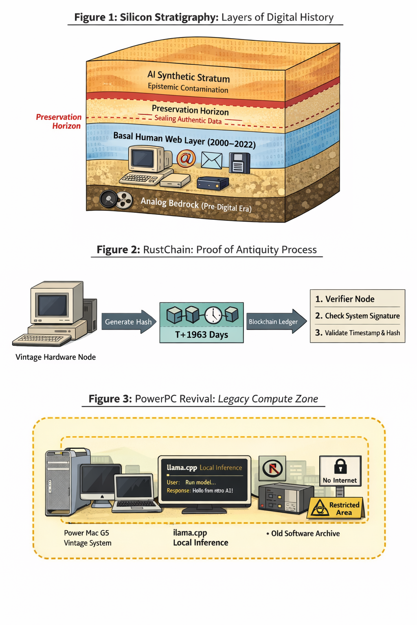

Figure 1. Silicon Stratigraphy concept figure: digital layer boundaries, provenance anchoring flow, and legacy compute-zone constraints used for controlled archival work.

1. ARCHAEOLOGICAL RELEVANCE

The method is directly relevant to standard archaeological research mediated by digital technologies. Teams routinely synthesize excavation notes, geospatial measurements, artifact catalogs, and legacy publications into interpretive narratives. If model-assisted summaries or generated reconstructions are not tightly linked to sources, subsequent researchers may inherit conclusions without being able to reconstruct the evidence path.

Silicon Stratigraphy addresses that risk by preserving a traceable path from claim to source. For example, if a typological claim is derived from mixed corpora (scanned reports, site images, and AI-assisted extraction), the lineage record identifies exactly which objects were primary evidence and which were transformations. This allows peer groups to accept, reject, or partially validate conclusions at the correct evidentiary layer.

The framework is equally relevant to digital heritage dissemination. Public-facing interfaces can expose derivative visualizations while preserving links to source records, thereby improving transparency for museums, educators, and community stakeholders.

1. IMPLEMENTATION NOTE

A working implementation accompanies this manuscript. The artifact package includes the manuscript PDF, primary figure, manifest file, SHA-256 hash list, and a machine-readable anchoring payload template in a public repository. The package is designed for independent verification and for straightforward adaptation to institutional repositories. The purpose of this implementation note is to demonstrate practical deployability rather than claim universal performance metrics.

1. EVALUATION CRITERIA

Evaluation is procedural and archaeology-oriented. A deployment is successful when it meets the following criteria: recoverability of source objects, zero unexplained fixity drift, complete source-to-derivative lineage, transparent timestamp/anchor checks, and clear disclosure separating evidence from generated interpretation.

These criteria prioritize research reproducibility. They can be measured quantitatively in future studies through inter-team replication exercises and blinded interpretation trials.

1. LIMITATIONS

This manuscript is a methods paper with one implementation context, so external validity is limited. The current work does not report controlled inter-lab trials, nor does it establish legal standards for evidentiary admissibility across jurisdictions. In addition, human-machine boundary classification can be ambiguous for records produced during transition periods where AI assistance is partial.

1. CONCLUSION

Archaeological and cultural heritage research now depends on digital records that are increasingly transformed by AI-enabled tooling. The core methodological requirement is therefore not tool prohibition but provenance discipline. Silicon Stratigraphy provides a concrete, auditable framework that preserves source integrity while allowing modern analytical workflows. The approach aligns with existing archival and provenance standards and addresses practical reproducibility needs in digital archaeology.

1. REFERENCES

Consultative Committee for Space Data Systems. 2012. Reference Model for an Open Archival Information System (OAIS). CCSDS 650.0-M-2. https://public.ccsds.org/pubs/650x0m2.pdf.

Digital Preservation Coalition. n.d. Digital Preservation Handbook. Accessed February 11, 2026. https://www.dpconline.org/handbook.

Kansa, Eric C. 2012. "Openness and Archaeology's Information Ecosystem." World Archaeology 44 (4): 498-520. https://doi.org/10.1080/00438243.2012.737575.

Lebo, Timothy, Satya Sahoo, and Deborah McGuinness, eds. 2013. PROV-O: The PROV Ontology. W3C Recommendation. https://www.w3.org/TR/prov-o/.

Marwick, Ben. 2017. "Computational Reproducibility in Archaeological Research: Basic Principles and a Case Study of Their Implementation." Journal of Archaeological Method and Theory 24: 424-450. https://doi.org/10.1007/s10816-015-9272-9.

National Institute of Standards and Technology. 2023. Artificial Intelligence Risk Management Framework (AI RMF 1.0). NIST AI 100-1. https://doi.org/10.6028/NIST.AI.100-1.

UNESCO. 2021. Recommendation on the Ethics of Artificial Intelligence. https://unesdoc.unesco.org/ark:/48223/pf0000381137.

Van de Sompel, Herbert, Michael L. Nelson, Robert Sanderson, Lyudmila Balakireva, Scott Ainsworth, and Harihar Shankar. 2013. RFC 7089: HTTP Framework for Time-Based Access to Resource States (Memento). IETF. https://www.rfc-editor.org/rfc/rfc7089.